The purpose of this assignment is to analyze the schematic of a circuit, built mostly with opamps, that implements a fully analog PID controller based on the architecture shown in the following diagram.
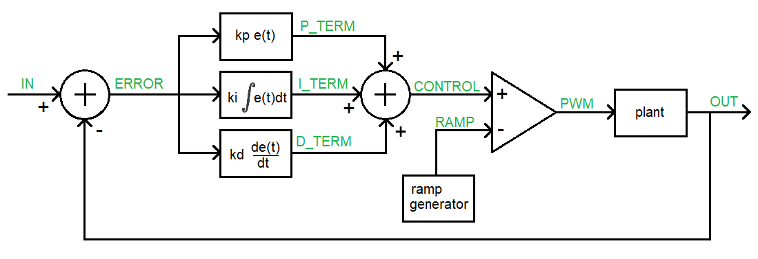
Figure 1: A PID controller subtracts the output from the input to generate an error signal. The error signal, its integral and derivative are multiplied by adjustable constants, added together, and then used to generate a PWM signal whose duty cycle is proportional to the control signal. The PWM signal is the input to the plant (thing that we want to control) which generated the observable output that is feedback into this loop.

Your task is to identify the building blocks in the schematic, analyze their behavior and relate these building blocks to the PID controller shown in Figure 1. When referencing opamps in the schematic, use the “ICxx” label, not the “TLC274P” label. When needed, assume that VCC=9V and VSS=-9V. Annoying to setup but this allows the error to be either positive or negative according to the sign of the voltage – very usefully semantically.

- The first summer junction
  - What opamp and resistors form the summer junction that outputs ERROR in Figure 1?
  - Write an equation for the output ERROR in terms of IN and OUT.
- The proportional term, P_TERM, is formed by two opamps. ERROR is the input to the first stage and P_TERM is the output from the second stage.
  - What opamp/resistors in the form the first stage of the P_TERM in Figure 1?
  - What is the range of the gain of this circuit? Make sure to include the sign.
  - What opamp/resistors form the second stage of the P_TERM in Figure 1?
  - What is the gain of this second stage?
  - What is the purpose of this second opamp stage?
  - Why didn’t I use a non-inverting opamp instead of this 2-stage approach? Hint, look at your answer for part b.
- The integral term, I_TERM, is formed by two opamps. ERROR is the input to the first stage and I_TERM is the output from the second stage.
  - What opamp/resistors in the form the first stage of the I_TERM in Figure 1?
  - Where have you seen this circuit before?
  - What opamp/resistors form the second stage of the I_TERM in Figure 1?
  - Write an equation for the output of the second stage, I_TERM, in terms of the input (call it ERROR) and C and R. Use C and R in your equation, not their values of uF and 10kΩ.
  - Why did I use an inverting integrator circuit instead of a non-inverting integrator?
- The derivative term, D_TERM, is formed by two opamps. ERROR is the input to the first stage and D_TERM is the output from the second stage.
  - What opamp/resistors in the form the first stage of the D_TERM in Figure 1?
  - Where have you seen this circuit before?
  - What opamp/resistors form the second stage of the D_TERM in Figure 1?
  - Write an equation for the output of the second stage, D_TERM, in terms of the input (call it ERROR) and C and R. Use C and R in your equation, not their values of 1uF and 10kΩ.
  - Why did I use an inverting differentiator circuit instead of a non-inverting differentiator?
- The second summer junction
  - What opamp and resistors form the summer junction that outputs CONTROL in Figure 1?
  - Write an equation for the output CONTROL in terms of P_TERM, I_TERM and D_TERM.
  - What value “should” the 3.3kΩ have? Why did I choose 3.3kΩ instead of this value?
  - Why did I use an non-inverting summer instead of the simpler inverting summer?
- The ramp generator is identical to the one you built in Lab 2. Using your lab results will simplify answering the questions in this section.
  - What components form the Schmitt Trigger Relaxation Oscillator (STRO)?
  - What is the period/frequency and duty cycle of the waveform generated by the STRO? Assume that potentiometer R35 is set to 0Ω.
  - Does R35 effect the time high or time low of the STRO waveform?
  - Components T1, T2, R29, and R30 forms a 0.7mA current source leaving the “bottom” of T1 (it’s collector). Assume that C10 is not populated, how long does it take to charge C9 from -9V to +9V? How would you describe the shape of the voltage vs. time waveform?
  - What is the role of Q1 in generating the RAMP waveform?
  - What is the role of R35 is this circuit?
- The comparator
  - Given RAMP (in red) and CONTROL (in blue) shown in the following timing diagrams, draw the output PWM signal using the open-loop opamp configuration shown in Figure 1.
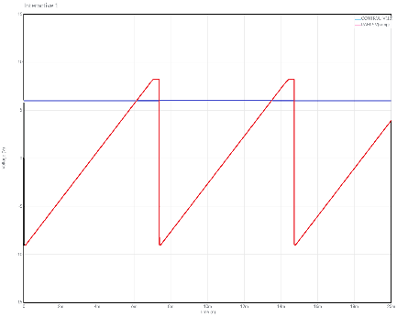 | 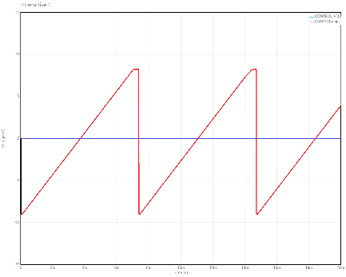 | 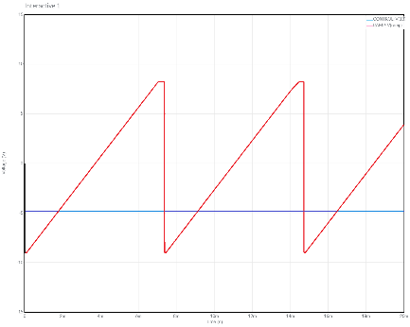

  - What is the relationship between the CONTROL signal and the duty cycle of the PWM signal? To determine this, plot the duty cycle vs control voltage and then write an equation to describe the straight line y=mx+b style.

- The plant, formed by the pair of opamp IC4D and IC4C in Figure 1, is a 4th order low pass filter (LPF) that converts the PWM output of the comparator into a DC signal whose voltage is proportional to the duty cycle over a -9V to +9V scale. The transfer function for IC4D is given by T1 and the transfer function for IC4C is given by T2.
$$T1\left(s\right)= \frac{66,840}{s^{2}+247s+66,840} T2\left(s\right)= \frac{297,100}{s^{2}+97s+297,100}$$
  - Use the following Mattab script to form the Bode Plot of the two stages of the low pass filter (LPF) in series.
% Make sure the control systems toolbox is installed
s = tf('s');
T1 = 66810/(s^2 + 247*s + 66810);
T2 = 297100/(s^2 + 97*s + 297100);
bode(T1*T2); waitforbuttonpress;
nyquist(T1*T2);

  - What is the attenuation of the LPF at low frequencies – express your answer in decibels.
  - the -6dB corner frequency in Hz. Remember that the Matlab plots in radians/sec.
  - Using the information in the Bode plot, how does the LPF convert the PWM waveform into a DC value?
  - What role is opamp IC4B and R38 serving?
  - I put IC4A into the circuit to buffer the plant from the other circuit elements. What is the gain of this stage? What is the effect of this stage on the gain of the previous stage.
  - Use the information in the Nyquist plot, is the closed loop feedback system with gain = 1 (integral and derivative gains = 0) stable?

This page was intentionally left blank in order to keep the page count correct.

Delete this page in Adobe and replace with PID controller schematic

